Mining Heritage, Green Future
Newsletter No.1 July 2023
Welcome to the first Mining Heritage, Green Future newsletter, which hopefully will be the first of many.
In these newsletters there will be news for you and your students about the following:
a) Heritage news b) Information about green jobs of the future c) What primary school pupils could do at secondary school d) News about green initiatives e) Schools sharing their news and ideas about what they can do to combat Climate Change
Please share the content of these newsletters with your students and colleagues if you work in a school!
Heritage News
8th July saw the 137th Durham Miners Gala, since the very first one took place at Wharton Park in Durham in 1871. Yet again a huge crowd of tens of thousands turned out on what was initially a warm, sunny day. It did get a bit wet later on! As ever, it was great to hear all the brass bands and see all the miners’ banners representing the mining heritage, which makes up such an important part of history in the Northeast.
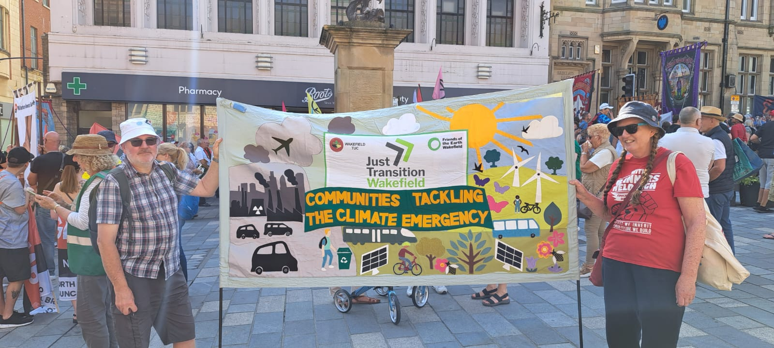
What was particularly interesting this year, was the fact that there were also environmental banners on display, such as this one from Wakefield, proudly held by Catherine and Stuart who do great eco education work in Yorkshire. I did sense that there was something of a different feel this year, with a greater emphasis on not only looking at how highly important energy resources were dug from the ground in the past, but also how we need new green jobs for our young people in the future, getting energy from the sun and the wind, the waves and the tides. There seemed to be the right combination of paying due respect to the hard, dangerous work that miners did in the past and the wonderful, vibrant culture they created in the villages and towns on the coalfield, while also looking to the future. Our young people need jobs in the new green industries. We have waited 40 years for a Just Transition, since so many of the mines closed; it’s time we had it.
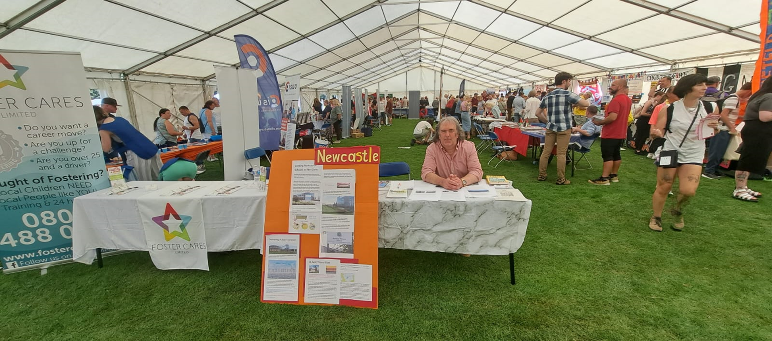
With this in mind, it was great that Durham Miners Association had allowed me to have a stall in their tent and the opportunity was much appreciated. I talked to a lot of interested people about how we should celebrate and pay respect to the great mining heritage in our region, which is such an important part of our story, while also looking to the future and the kind of energy we will have then. It was great that everyone I spoke to agreed that it was right to celebrate our heritage, whilst also looking to the greener future ahead. We can truly see ourselves as an energy producing region; that energy used to be coal, but with the development of projects such as the Dogger Bank project at Port of Tyne, the new housing estate near Seaham, where the houses will be heated by hot water from the old mine workings nearby and hopefully a new giga factory at Blyth, we will be at the forefront of the new green industrial revolution, such as we are the forefront of the first industrial revolution. We can take the great legacy of community and spirit and our heritage of innovation into the future, while developing the new green energy we will all need.
…………………………………………………………………………………………………………………………………………………………………………………………………………………………………………………………………………………..
The Dogger Bank Project
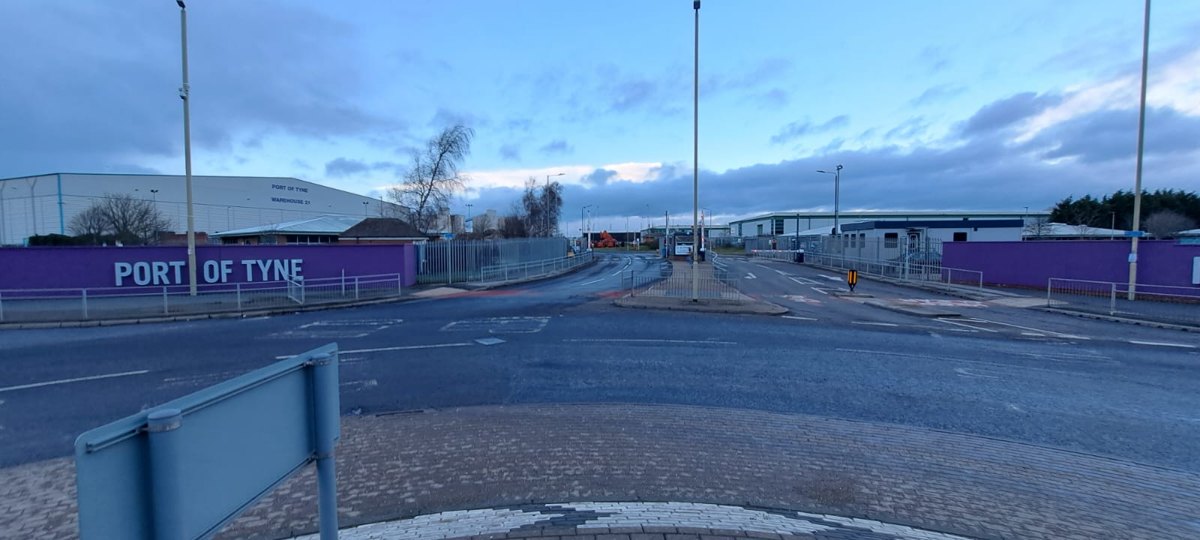
According to the official website, the Dogger Bank Project is, “Dogger Bank Wind Farm is an offshore wind farm being developed in three phases – Dogger Bank A, B and C – located between 130km and 190km from the North East coast of England at their nearest points. Collectively they will become the world’s largest offshore wind farm.
Each phase will have an installed generation capacity of 1.2GW and represents a multi-billion pound investment. Combined, they will have an installed capacity of 3.6GW and will be capable of powering up to 6 million homes annually.”
Much of the work for the Dogger Bank Project is taking place in South Shields at the Port of Tyne, utilising some of the many the skills workers already have in our region. It is a sign of the kind of green jobs your young people may have in the future, especially as it is estimated that a total of 500 000 new green jobs will need to be created in the UK, for us to complete the decarbonisation of the economy.
…………………………………………………………………………………………………………………………………………………………………………………………………………………………………………………………………………………
Homes to be heated by warm water from flooded mines
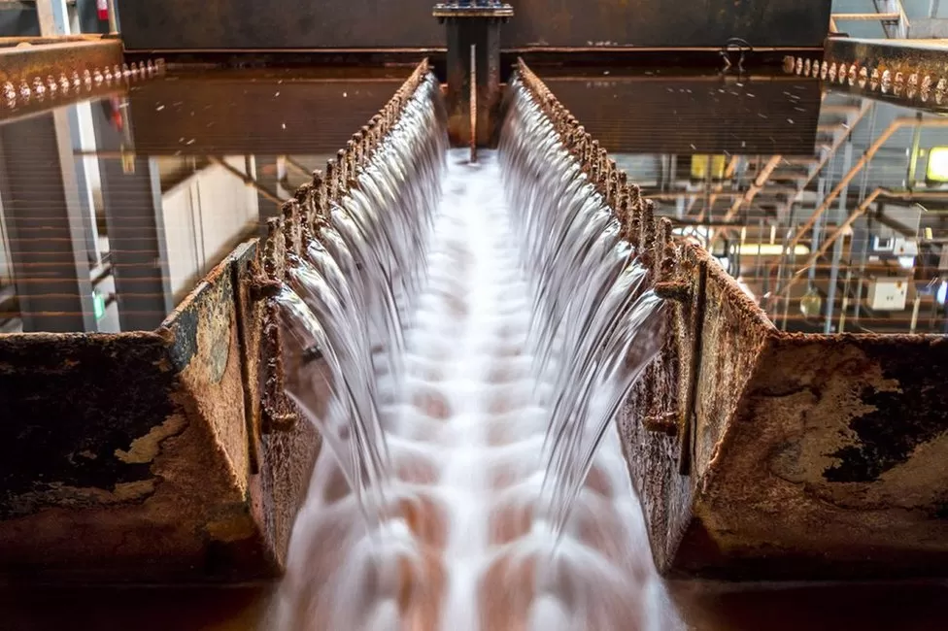
Water from Dawdon mine will be sued to heat a garden village in County Durham
It was reported by the BBC on 9th June 2020, that a new garden village in County Durham would soon be getting its heat from a surprising source: it will be warmed by water from a disused mine. It was noted that, “the temperatures are raised naturally, by heat from the Earth's crust. The water is then pumped up from flooded shafts and used to heat the whole district using a single system.” This is a wonderful part of our great mining heritage in the region and the BBC commented that, “1,500 residents of South Seaham Garden Village shouldn’t notice that the warmth from the radiators derives from the dust-smeared sweat of their forebears.”
Green Jobs
Wind Power – jobs in offshore wind
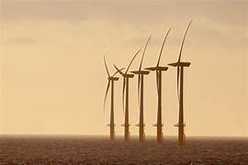
Wind farm in the North Sea
It has been estimated by the Campaign Against Climate Change Trade Union Group (CACCTU) that by 2038, we will need a workforce of around 70,000 in this country involved in developing offshore wind, based on a target of 100 gigawatts of installed energy. It is thought that over half of these jobs, as many as 59% would be in manufacture and the engineering roles supplying the necessary materials and other supplies. A further 24% of these jobs, around 14,000 jobs in all would be in operation and maintenance of wind turbines, with 11% in installation and 6% in other roles.

It was noted in The Guardian on 28 May that more onshore wind turbines had been built over the previous year in war-torn and ravaged Ukraine than in England. In a year that has seen record temperatures in England, with the 400c barrier being broken, this is clearly an unacceptable state of affairs. There are varying estimates as to how much onshore wind power production could develop by 2038, from 96 gigawatts to as much as 214 GW. It is also estimated that between 8 and 19% of land in this country is suitable for onshore wind production. Consequently, CACCTU estimate that the workforce involved in developing onshore wind would have to increase to at least 28,000, with a further 14,000 jobs in the supply chain.
………………………………………………………………………………………………………………………………………………………………………………………………………………………………………………………………………………
What could pupils learn at Secondary School?
When pupils get to secondary school they will be able to pursue any interests they have in developing their skills ready for the world of engineering, skills that we desperately need as we decarbonise the economy and move towards renewable energy.
Here are some of the skills pupils will use and develop when they get to secondary school, as specified in the National Curriculum:
▪ use research and exploration, such as the study of different cultures, to identify and understand user needs
▪ identify and solve their own design problems and understand how to reformulate problems given to them
▪ develop specifications to inform the design of innovative, functional, appealing products that respond to needs in a variety of situations
▪ use a variety of approaches [for example, biomimicry and user-centred design],to generate creative ideas and avoid stereotypical responses
▪ develop and communicate design ideas using annotated sketches, detailed plans, 3-D and mathematical modelling, oral and digital presentations and computer-based tools

Making things
▪ select from and use specialist tools, techniques, processes, equipment and machinery precisely, including computer-aided manufacture
▪ select from and use a wider, more complex range of materials, components and ingredients, taking into account their properties

Evaluate
▪ analyse the work of past and present professionals and others to develop and broaden their understanding
▪ investigate new and emerging technologies
▪ test, evaluate and refine their ideas and products against a specification, taking into account the views of intended users and other interested groups
▪ understand developments in design and technology, its impact on individuals, society and the environment, and the responsibilities of designers, engineers and technologists

Technical knowledge
▪ understand and use the properties of materials and the performance of structural elements to achieve functioning solutions
▪ understand how more advanced mechanical systems used in their products enable changes in movement and force
▪ understand how more advanced electrical and electronic systems can be powered and used in their products [for example, circuits with heat, light, sound and movement as
inputs and outputs]
▪ apply computing and use electronics to embed intelligence in products that respond to inputs [for example, sensors], and control outputs [for example, actuators], using
programmable components [for example, microcontrollers]
…………………………………………………………………………………………………………………………………………………………………………………………………………………………………………………………………………………
What is happening in Northeast schools?
A lot of great eco-education initiatives are taking place in the Northeast. One of the schools where a lot of good things are happening is Corbridge middle school in Northumberland, where Meryl Batchelder teaches Science. Meryl is an officially accredited UN Climate Change teacher and is doing great work at Corbridge Middle School.
At Corbridge Middle School, there is a scheme about finding tomorrow’s Climate Scientists with the help pf Royal Society partnership grants. They have developed a weather station working with Newcastle University taking data about local heavy downpours, as part of a STEM project Also, pupils have been to Newcastle University, putting in for Crest awards and pupils have talked at a sustainability conference, the work to careers and industry, while pupils have talked to the Royal Society.
Please let me know about the eco-education initiatives at your school. It would be great to share news… and ideas!

Peter Sagar July 2023.

