Torn from Home: from Bosnia to Heaton
On 4 May 1980 a major news story broke. For all its importance, it probably didn’t have a huge resonance in Heaton, but it would nevertheless go on to have an impact on the life of that part of Newcastle. It was on that day that President Tito of Yugoslavia died. Tito and his authoritarian rule had helped to keep the former Yugoslavia together after the nightmares of WW2, yet in little over ten years after Tito’s death, Yugoslavia would be torn apart by ethnic conflict and Smajo Beso and his family would be torn from home only to find a safe place of refuge in Heaton. This is the story of Smajo and his family….and other Bosnians who fled the deadly war and horrific concentration camps of Bosnia and came to the sanctuary of Tyneside will have similar tales to tell.
Smajo Beso was born on 29 March 1985 in a little town in Bosnia called Stolac. Although born in Stolac, which is a town of 18,000 people, he actually grew up in a small village called Barane. Smajo’s early childhood was pretty idyllic, living under a beautiful mountain, surrounded by nature. In the village there were only 44 homes and as a young boy this gave Smajo a great sense of freedom and adventure.
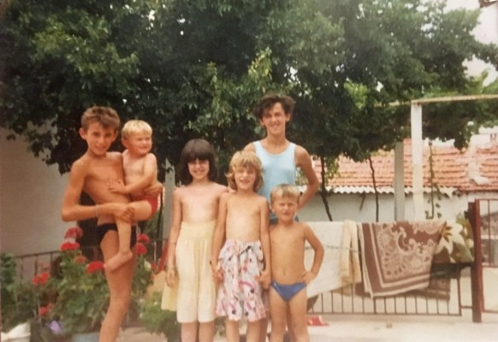
Smajo is the little blond boy being held on the left

Smajo makes it clear now that while the conflict in Bosnia is often explained by using the argument that there were ancient hatreds, which just exploded like a deadly human volcano and there was an inevitability about it all, he doesn’t doesn’t agree. He says that this is an outsiders’ explanation and simply not true. On the contrary, Bosnia was a country where people of different religions co-existed very peacefully. Jews, for example, were made to feel welcome in Bosnia when they were not welcome in other parts of Europe.
Smajo was brought up not to differentiate in anyway between people of different religions. Although from a Muslim family, he remembers going to a neighbouring Catholic family’s home at Christmas, while they bought Smajo’s family presents at Eid. Smajo was raised to know that people celebrate different holidays at different times, but they were not different as people. In Bosnia the outward appearance of religion was not obvious, particularly from a child’s perspective; there were a lot of mixed marriages and people were not treated differently.
Signs of change
When asked how he noticed as a young boy that things were going wrong, Smajo replied that it was ‘not overnight’. However, he does remember one incident vividly. Smajo was six years old and was living in a new home his family had just built. Smajo was playing outside but when he ran back in, he saw his mother crying, while watching television.
Looking back it was 1991 and Smajo thinks it was probably something bad happening around the area of Croatia and northern Bosnia. Smajo also remembers that, ‘our Croatian friends disappeared overnight’. They were worried about the Second World War and that some Croatians, working in tandem with the Nazis, had been involved in massacres of Serbs. In the end only a few elderly Croatians stayed and then eventually only Smajo’s family was left in the village surrounded by the Serb army.
Smajo’s grandad and his brothers had helped to save Serb villages in the Second World War. Consequently, local people went into the street to say Smajo’s family should be protected. They were friends and still coming round – but now in uniforms. They were still friendly and Smajo’s dad knew the commander and he was able to reassure Smajo’s family that even though they were Muslim they would be alright. However, local friendly soldiers started being replaced by others from further away, from Monetengro and Serbia and some locals changed. One person, who had been friendly, came round sharpening knives, saying that he was going to kill Smajo’s family. He had been friendly just a week earlier.
Concentration camps
However. it was notable that other Serbs still came at night to bring food to Smajo and his family at great risk to their own lives, even when it came to really bad times. There was still one local hospital open but when Smajo had to be taken there because he was ill, soldiers at roadblocks wouldn’t let Smajo and his father back in to the village. The soldiers told them to go a nearby concentration camp. Fortunately one soldier recognised the family and got into the car with them, so they were able to go to another house. The son of another friend got into his uniform and also got into the car. Smajo and his family got back to safety. Smajo’s dad’s cousin not so lucky. He was taken to a camp and died a few days later after coming back. It was said to be a heart attack. Whatever the truth, it was surely brought on by torture.
Inevitably, there was a lot of propaganda, with rumours of massacres. By now Smajo and his family were completely cut off. Smajo’s dad felt compelled to patrol with an old gun. His own father had fought with the Partisans against the Nazis in WW2 , but now Smajo’s dad was up against what was still then the Yugoslav army, then the fourth biggest in Europe. At one point a truck of Serbs came to torture and kill Smajo and his family, but were stopped by a Serbian friend.
Smajo’s family escaped from the isolated village of Barane and made it to Stolac, where there were other Muslims and there would be safety in numbers. Smajo’s dad joined with the Croatian army to fight against the Serbs but after a year all the Muslim men in Stolac were sent to a concentration camp – by the Croatians. Still a small child, Smajo escaped through a place of happy childhood memories from just a few years earlier. How different it all was now. His first taste of war was playing behind his house and hearing shells. Smajo has noted that even when young you know when danger is around you. He understood then the panic he had seen earlier in the adults around him and what they had been talking about.
Smajo’s father and other men were arrested in July 1993 and put in a concentration camp by the name of Dretelj, which was to become known as the Camp of Death. Smajo’s father lost 27kg in his first few weeks there. He had been fighting the common enemy for the ideal of a multicultural Bosnia. Around the same time, Smajo and his friend had been outside playing in the town of Stolac, when they saw many trucks coming down the road. One of Smajo’s friends saw an uncle of his in the trucks. The men were being taken to be interrogated. Smajo’s dad went back to the front line to wait for inevitable capture while Smajo and the rest of the family remained at his uncle’s house in Stolac for over a month. The uncle was taken a few days later and they saw it happening. He had not been on the front line due to having an injury. One man who came to take him was his daughter’s boyfriend. He didn’t care who he took from Stolac. On 4 August, Smajo’s family were expelled from their old home and taken to a metal factory (Smajo’s uncle had been expelled from his home a month earlier and taken to the same metal factory to be searched and interrogated.) Smajo’s mother was forced to sign something to give away her earrings for ‘safe-keeping’.
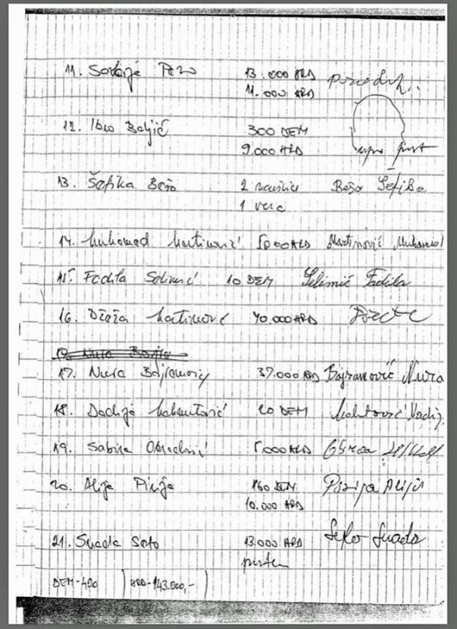
Document on which Smajo’s mum had to sign away her earrings ‘for safe keeping’
From there Smajo and his family were loaded onto trucks and driven until they were near Bosnian-controlled territory and then forced to march to safety. It was very hot and at one point Smajo stepped over a dead body. The elderly died on the side of the street and they were all shelled and shot at.
Escape to the UK
From August 1993 until July 1994 the family stayed in Mostar with Smajo’s mum’s sister. His dad was writing to the family through the Red Cross so they knew that at least he was alive. They had found out just before they left Stolac and then heard nothing for months. The camp he was in was eventually discovered by the Red Cross but by then Smajo’s dad had been there for four months, with nothing to eat but watery stew served in a tiny pot. The boiling hot stew was often so hot he passed it on without having any as it burnt his insides, so on many days he simply didn’t eat anything. In four months he lost 27 kg. The Red Cross took out the 500 men in the worst condition to an island off Croatia where they were fed and treated. From there, Smajo’s father came to the UK, arriving on 19 January 1994. He was told he could go anywhere except Asia, Africa – or back to Bosnia.
Smajo’s father had to take a ferry, then a bus to Zagreb, walking on enemy territory, when he could have been killed any time. Indeed at one point he had to move away from Muslim haters on the ferry. He was then taken to a meeting point in Zagreb and then flew to the UK on a charter flight for refugees. Eventually, he reached Newcastle.
While all this was going on what happened to the town of Stolac? Stolac had for long been known as the ‘Bosnia Museum in the open’. It had the best conserved historic core of any town in Bosnia, with wonderful archives and museums. The Croatian troops who went there in August 1993 torched every sign of Muslim existence – with even the local mosque foundations dug up and archives burnt.
This was the dreadful situation Smajo and his family were fleeing from when they were torn from home to land in the Heaton area of Newcastle. Smajo himself had just turned nine and on hearing that he was coming to the UK he found it on a map. He says now that, ‘it looked small!’He was however excited to get out. A peace agreement with Croatians had been signed, but no agreement had been concluded with the Serbs and the nightmare of the genocide at Srebrenica was still to come a year later. However Smajo was also sad at leaving grandparents, family and friends behind. It was particularly difficult for his mother; she was leaving her parents behind to see her husband in Newcastle. Thankfully they did survive. But around the same time the dangers of staying were sadly brought home only too clearly, when Smajo’s aunt (his mother’s sister), was killed by Croatian bombs well away from the front line. It was a senseless killing.
Refugees in Newcastle
In June the Red Cross picked up Smajo and his immediate family so that they could join Smajo’s father. On route, they were regularly stopped by Croatians at road blocks before reaching a refugee camp in northern Croatia. They were then driven to Zagreb, before flying to London and a short stay in a refugee centre there – all part of the agreement signed by John Major’s government – before finally flying north to Newcastle. Newcastle Central MP Jim Cousins was among those who helped them get to Newcastle.

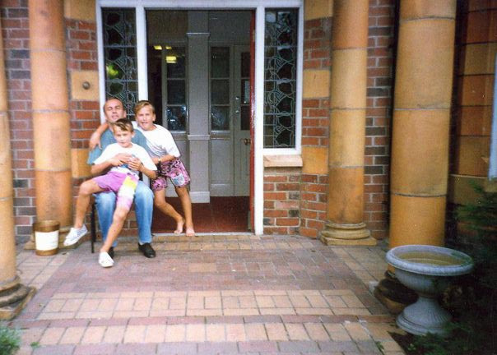
Smajo, his brother and father, Gosforth, 1994
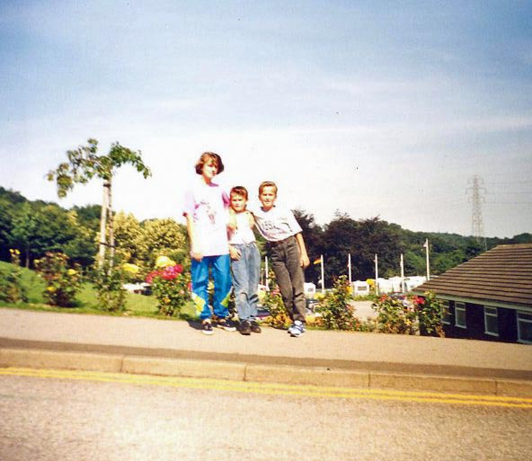
Smajo, his brother and sister, 1994
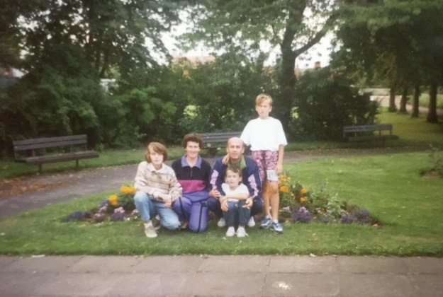
Family photo, 1994
At first Smajo’s family lived in a refugee centre in Gosforth before moving to a house in Heaton, just off Heaton Park Road. Coming from a war zone Smajo found Heaton very peaceful – there was no sound of shooting. At night however he found himself having nightmares about Bosnia as he began to process what had happened. One particular recurring dream was of waiting in line for food. On one occasion when doing this for real back in Bosnia, Smajo and his family had been shelled, but until now, he had blocked this from his memory.
Chillingham Road schooldays
Soon it was time for Smajo’s first day at Chilingham Road Primary School. He remembers that he was taken there with a Croatian interpreter. However, the school had not been told that he was from a war zone. What with the bad memories and no English language, Smajo was very quiet in his early days at Chillingham Road. Consequently, the school requested a meeting with his parents to discover why he wasn’t talking and subsequently things improved.
At this point the deputy head of Chillingham Road Primary School at the time, Claire Webster Saaramets takes up the story. Claire remembers going to the school gates that first morning and that she had no real knowledge of what Smajo and other children from Bosnia had gone through. She had seen the news from Bosnia on the television, but that was all. Chillingham Road Primary School was already a mixed community and very integrated. However Smajo was so quiet, not saying very much at all and this lack of English language left teachers unaware of the trauma he had gone through.
After the horrors of Bosnia, living in Heaton and attending Chillingham Road Primary School was a very positive experience for Smajo and others. They were able to feel a sense that they could just come and be who they were. Music was important and was one thing that could be shared. After Smajo’s parents went back in to school there was lot of additional help.
There was often a song at the end of class and Claire taught the children how to sing it in Bosnian. So it was that a year 5 class in Heaton learnt to sing in Bosnian, their class song with the title of ‘Goodbye my Friends’, a poignant song about leaving friends behind at the end of the school day. Smajo remembers this as, ‘just the most incredible and biggest act of kindness ever.’ He goes on to comment that, ‘this was something so simple but something so incredibly huge for me. It was a piece of home. I remember that first day walking home from school with a smile on my face. That’s no exaggeration. It was incredible how welcomed I felt, how human and real I felt. What Claire did I will never forget for the rest of my life and we can all learn so much for that one act.’
Smajo also remembers drawing two soldiers with a flag of peace and as his English improved was able to produce an autobiography with a picture.
Schools in Heaton did a lot to help the Bosnian community and others fleeing the war in the former Yugoslavia. Chiilingham Road Primary School held a mini project around peace, helping pupils to feel safe. Meanwhile nearby Ravenswood Primary School initiated a campaign to try and stop the deportation of a pupil and their family back to Croatia. The project at Chillingham Road was about making sure it was safe place, while the school was also used a community centre for several years with the Bosnian flag in on the wall of the dining hall. Members of the Bosnian community met every Friday and they also received great help from the caretakers at the school.
Smajo faced a number of initial problems at school at Chillingham Road Primary. Most obviously there was the language barrier. Consequently, at Chillingham Road it took quite a long time for him to make friends. He would stand forlornly looking and watching on the playground. In his early days at Chillingham Road, Smajo would wait outside every morning, until it was time to come in. Fortunately it was a good Year 5 group and the teachers encouraged the playing of games, which Smajo could join in with. Ultimately it was the international language of football which helped, as playing football was the way he got friendly with people; Smajo had also played football in Bosnia.
At home in Heaton
As Smajo settled into his new life in Heaton, he found both good and bad things about it. On the down side, nearly all his family and friends were still in Bosnia and Smajo found himself feeling homesick. He and his family had a home, but it didn’t feel like a home at first. Happily, all that has changed and Heaton and Newcastle are very much home now.
Smajo says that people in Heaton and the north east of England share a lot of similarities with Bosnians – they are friendly, with a lot of time for people, just like people in Bosnia. The Bosnian community helped each other, but there were so many other people who helped them. Consequently, they have integrated well, with many Bosnians becoming doctors or working in other professions. Smajo is proud to be Bosnian, but also proud that Newcastle is his home. Heaton is very much their home and most Bosnians in Newcastle live in Heaton and High Heaton.
Smajo sometimes thinks of what might have happened if he and his family hadn’t come to Heaton. He states that they had no option but to flee. They escaped because of the agreement signed by the British government and that was what brought them here. They never knew how long they would stay here but are now glad that they did.
In terms of what people in Heaton and Newcastle can do to help those torn from home at time of war or other crisis, Smajo simply says to give them a warm welcome. It is a great credit to the people of Heaton and Newcastle that Smajo thinks that they should do whatever was done in the 1990s for the Bosnian community. Smajo notes that people here did that extra bit for them, acts of kindness from people in Heaton, such as having the class song translated into Bosnian.
And what is Smajo doing now? He is busy completing his Phd in Architecture and teaching at Newcastle University. He also spends a lot of time telling others of the experiences of himself and others in Bosnia in those dark days in the 1990s and helping people to understand what happened and how we must always be aware of the signs of impending genocide. The struggle against hatred and prejudice goes on.
Acknowledgements
Researched and written by Peter Sagar of Heaton History Group. Interviews with Smajo Beso and Claire Webster-Saaramets, Newcastle-upon-Tyne, 21 March 2019 with further comments from Smajo, April 2019.
Additional Source
Wikipedia https://en.wikipedia.org/wiki/Josip_Broz_Tito

